Audit form: Occupational therapy in neonatal services and early intervention – practice guideline. Second edition

Audit Form
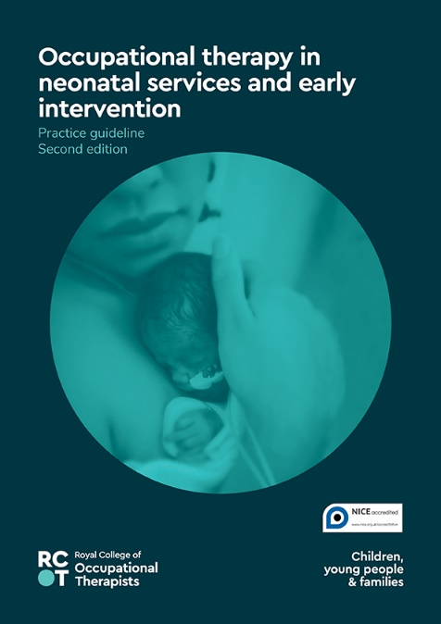
This audit tool is to be used with the evidence-based practice guideline Occupational therapy in neonatal services and early intervention – 2nd edition (RCOT 2022).

These evidence-based recommendations are not intended to be taken in isolation and must be considered in conjunction with the contextual information provided in the full guideline, together with the details on the strength and quality of the recommendations. The recommendations are intended to be used alongside clinical expertise and, as such, the occupational therapist is ultimately responsible for the interpretation of the evidence-based guideline in the context of their specific circumstances and the people accessing their services.

The full practice guideline together with implementation resources can be found on the Royal College of Occupational Therapists website: https://www.rcot.co.uk/practice-resources/rcot-practice-guidelines

Reference
Royal College of Occupational Therapists (2022) Occupational therapy in neonatal services and early intervention. 2nd ed. London: RCOT.

Please ensure you save this document to your computer otherwise your changes will be lost.

Date of audit |  | Auditor |  | Role
Location |  |  | Review due date

Recommendations

Occupation-based assessments |  | What is your current practice? How do you evidence this? | Comments  Actions to be taken by whom and by when
 | It is recommended that occupational therapists safely and appropriately assess the neurobehavioural status of the high-risk infant, in order to plan/deliver developmentally supportive care.
 | It is recommended that occupational therapists assess neurobehavioural and neurodevelopmental status to provide guidance and identify infants appropriate for developmental follow up following discharge.
 | It is recommended that occupational therapists liaise with community teams and assess neurodevelopmental status for high-risk infants in the first two years of life to provide guidance and implement early intervention services where indicated.

Developmentally supportive care |  | What is your current practice? How do you evidence this? | Comments  Actions to be taken by whom and by when
 | It is recommended that developmentally supportive care principles are implemented for high-risk infants admitted to neonatal units to enhance short term health and developmental outcomes.
 | It is recommended that occupational therapists promote an appropriate developmental environment, based on the infant’s age and status and individual needs.

Pain management |  | What is your current practice? How do you evidence this? | Comments  Actions to be taken by whom and by when
 | It is recommended that occupational therapists promote the use of non-pharmacological pain management strategies (e.g. skin-to-skin care, facilitated tucking etc) by all caregivers (parents and practitioners) for pain management during appropriate, planned, painful caregiving procedures.
 | It is recommended that occupational therapists support parent understanding and engagement in appropriate pain management strategies to enable them to provide sensitive support to their infants and promote parent self-efficacy.
 | It is recommended that occupational therapists work with the neonatal team to promote routine assessment of neonatal pain and identification of appropriate pain management strategies.

Skin-to-skin (kangaroo) care |  | What is your current practice? How do you evidence this? | Comments  Actions to be taken by whom and by when
 | It is recommended that occupational therapists collaborate with the neonatal team to facilitate parent engagement in skin-to-skin care for high-risk infants to promote pain management, physiological regulation and infant weight gain.
It is recommended that occupational therapists collaborate with the
neonatal team to facilitate parent engagement in skin-to-skin care for high-risk infants to promote breastmilk feeding, parent wellbeing and parent self-efficacy.

Touch |  | What is your current practice? How do you evidence this? | Comments  Actions to be taken by whom and by when
 | It is recommended that occupational therapists facilitate the provision of positive touch and infant massage* by parents/primary caregivers to decrease infant stress and improve state and physiological regulation.
It is recommended that occupational therapists facilitate the provision of positive touch and infant massage* by parents to decrease parent anxiety and promote parent mood and parent-infant relationship.

* NB: Please see information in section 5.5.1 of the full guideline regarding the requirement for specialist training/certification to facilitate parent-delivered infant massage with high-risk infants in the neonatal unit setting.

Postural support |  | What is your current practice? How do you evidence this? | Comments  Actions to be taken by whom and by when
 | It is recommended that occupational therapists collaborate with the neonatal team to facilitate individualised postural support recommendations for infants that promote infant motor outcomes, self-regulatory behaviours and prevent respiratory compromise.
 | It is recommended that occupational therapists review the selection and use of neonatal postural support aids for their ability to promote infant motor outcomes, the development of infant postural control and self-regulatory behaviours.
 | It is recommended that occupational therapists use a postural support assessment tool to support the education of the neonatal team and promote individualised positioning of high-risk infants in the neonatal unit.

Infant feeding |  | What is your current practice? How do you evidence this? | Comments  Actions to be taken by whom and by when
 | It is recommended that occupational therapists collaborate with the neonatal team to support parents in reading and responding to infant feeding readiness cues to promote the co-occupation of feeding in the neonatal unit and following transition to home.
 | It is recommended that occupational therapists promote an appropriate environment in the neonatal unit to support parent/infant participation in early feeding experiences. Environmental support factors may include space, seating, privacy, sensory environment and NICU culture.

Parent engagement |  | What is your current practice? How do you evidence this? | Comments  Actions to be taken by whom and by when
 | It is recommended that occupational therapists work with parents of high-risk infants to support parenting roles and relationships, and to provide sensitive and appropriate parent engagement in the infant’s care in the neonatal unit.
 | It is recommended that occupational therapists facilitate the development of co-occupations related to activities of daily living (including, but not limited to, feeding, bathing, nappy changing, dressing and play activities of daily living) with preterm and low-birthweight infants to ensure sensitive and appropriate caregiving and promote occupational performance of infants and parents.
 | It is recommended that occupational therapists working with families of high-risk infants build a positive therapeutic collaboration with parents to enhance parental learning about their infant both during and following the transition to home.
 | It is suggested that occupational therapists explore both traditional and innovative methods (e.g. video-conferencing) of supporting families post- discharge from the neonatal unit as a means of promoting parent confidence and competence in caring for their infant following the transition to home.

Parent support |  | What is your current practice? How do you evidence this? | Comments  Actions to be taken by whom and by when
 | It is recommended that occupational therapists support engagement in parenting occupations in the neonatal unit and following discharge (including, but not limited to, reading infant cues, guided participation in care, skin-to-skin, positive touch and holding) to promote decreased parent stress and positive improvements in parent–infant relationship and self-efficacy.
 | It is recommended that occupational therapists employ parent-focused interventions that incorporate parental attunement in order to reduce the psychosocial impact of delivering a high-risk infant, foster sensitive nurturing behaviour and promote the cognitive development of preterm infants.
 | It is suggested that occupational therapists engage parents in brief activity-based interventions during their infant’s admission to the neonatal unit and that this can have a short-term effect in lowering parent anxiety.
It is recommended that occupational therapists consider the use of
e-health interventions (e.g. web-based platforms, mobile apps, video-conferencing etc) to support parent engagement, particularly when parent presence may be interrupted.
It is recommended that occupational therapists employ the use
of parent-focused psychosocial interventions to decrease parent stress and anxiety and promote parent coping, confidence and early parent-infant relationships.

Identifying developmental concerns |  | What is your current practice? How do you evidence this? | Comments  Actions to be taken by whom and by when
 | It is recommended that occupational therapists should be involved in the screening and assessment of high-risk infants for problems related to cognitive performance and social interaction, to support the development of the infant’s occupations, with referral to early intervention services as indicated.
 | It is recommended that occupational therapists should be involved in the screening and assessment of high-risk infants for problems related to functional motor skills, to support the development of the infant’s occupations, with referral to early intervention services as indicated.
 | It is recommended that occupational therapists should be involved in the screening and assessment of high-risk infants for problems related to sensory processing difficulties, to support the development of the infant’s occupations, with referral for early intervention services as indicated.

Early intervention |  | What is your current practice? How do you evidence this? | Comments  Actions to be taken by whom and by when
 | It is recommended that occupational therapists provide early developmental intervention programmes for preterm infants to promote improved cognitive performance through the preschool years.
 | It is recommended that occupational therapists provide home-based early intervention programmes for infants born <30 weeks’ gestation in the first year of life as this may result in decreasing parent anxiety.
 | It is recommended that occupational therapists facilitate individualised functional motor interventions for high-risk infants and young children to promote engagement in early occupations such as play, exploration and participating in personal care (activities of daily living).
 | It is recommended that occupational therapists incorporate home routine/occupation-based approaches in early intervention programmes for children at risk for developmental delay as a means of promoting occupational performance.
 | It is recommended that occupational therapists be routinely referred preterm infants with the following co-morbidities: septicaemia, extremely low birthweight (ELBW), chronic lung disease, periventricular leukomalacia (PVL) or intraventricular haemorrhage (IVH) (grade III–IV), for early intervention.
 | It is recommended that occupational therapists working in early intervention settings with high-risk infants consider key elements when building a therapeutic collaboration with parents – promoting effective collaboration amongst multiagency providers, supporting family social/emotional needs in addition to infant developmental concerns, and consistency of service provision.

